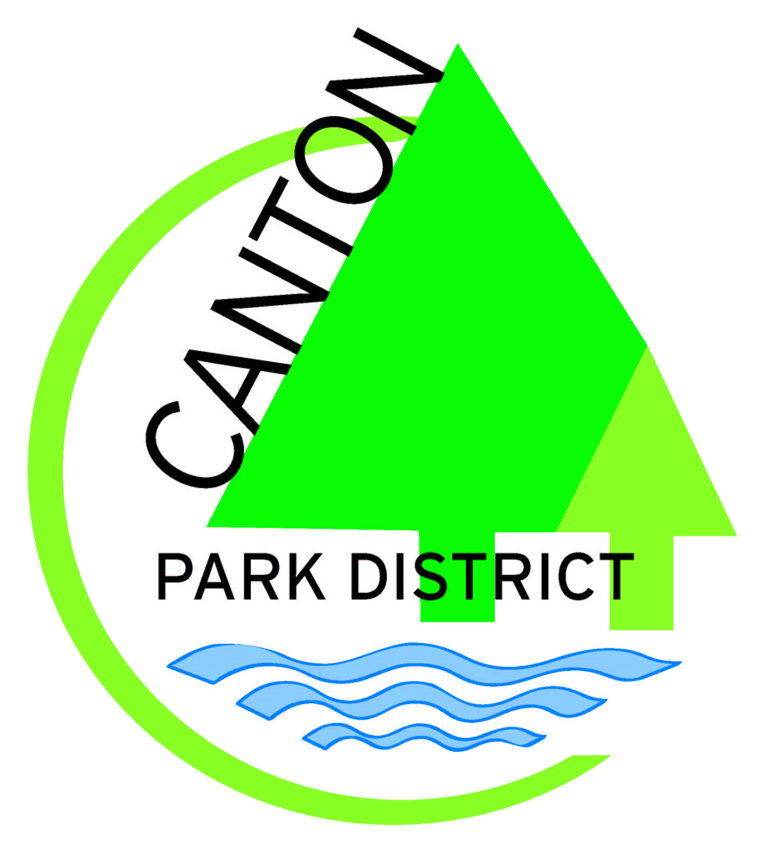


Canton Area Chamber of Commerce and
Canton Park District are hosting
Community Work Day - Saturday, April 26
Rain Date May 3

Project Registration – Return by April 18th

Agency Name _______________________________________

Contact at Agency & Phone Number ___ _________

Please describe the project (s) that needs to be completed: (please list all)

________________________________________________________________________
________________________________________________________________________

________________________________________________________________________

Will this require skilled labor (Example: carpentry…) Yes ___ No___

How many people will it take to complete this/these projects in a timely manner?

________________________________________________________________________

Approximately how long do you think this/these projects will take?

________________________________________________________________________

Is this something that a family could bring their children to assist with? _________

How many volunteers/employees will be at your location to assist?

___ _________________________________

